Back to image results
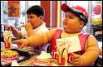
See full size image
406 x 266 - 63k - jpg - therawfeed.com/pix/fat_kids_lovin_it.jpg

